Game “Robocode”
Team member: Wang zhe, Weng Guoyang, Sun Wenbin, Tian Linwang, Wang Shuo, Wang Junjie

- Introduction
1.1 Basic goal
Robocode competition is all about two things:
Movement: Avoid getting hit too much.
Targeting: Try to predict where the opponent(s) will move and hit them as much as possible.
1.2 sophisticated techniques
Many sophisticated techniques have emerged. In particular, many top bots utilize:
Wave Surfing - Adapting your movement and trying to avoid getting hit the same way twice.
Statistical Targeting - Collect data that describes the targeting situation together with what would have been the correct decision for each situation. Use this data to make targeting decisions.
GuessFactor Targeting- The best known form of Statistical Targeting where the stats for enemy robots are each expressed through a number between -1.0 and 1.0 (the "GuessFactor").
Pattern Matching- Tries to match patterns of observed behavior with previously observed patterns, and make decisions on targeting based around that.

2. Strategies
2.1 Movement feature
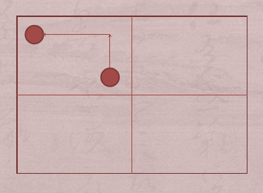
For the initial location is random, we divided the field into four area. And move to the nearest corner for every area.
The speed and direction are random.
However, it only move along the boundary.
We imagine that there is an invisible wall inside the field.
2.2 Attacking feature
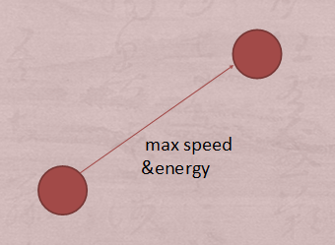
After finding an enemy, it will fire. The firepower bases on the distance. If the enemy is too far away, it will not fire and search other enemies.
If there is only one other tank, it will lock on that one. Use its max speed to follow it and use its max energy to fire it.
2.3 Scanning feature
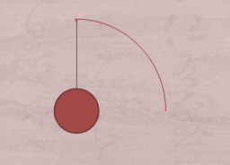
It turns around the radar all the time.
It will stay on every other tank for several seconds to check their energy.

3. Algorithms

headingRadian

direction

Enemy.bearingRadian

- After finding the enemy, Random Man gets the angle headingRadian and angle enemy.bearingRadian and the enemy’s distance, velocity and heading radian.
- We can use the angle headingRadian, the angle enemy.bearingRadian, we can get the direction ( direction = enemy.bearingRadian – headingRadian )
- According to the direction and the distance to get the enemy’s coordinate. (x-axis = distance * sin (direction ), y-axis = distance * cos(direction)).
- Then we can get the time 1 that Random Man takes to turn gun to aim at the enemy (enemy.bearingRadian / GUN_TURNING_RATE) and the time 2 that the bullet takes to reach the enemy (distance / BulletSpeed). And we get the total time (total time = time 1 + time 2)
- According to the times, we can estimate the coordinate of the enemy (new x-axis = x-axis + velocity * total time * sin(heading radian ), new y-axis = y-axis + velocity * total time * cos(heading radian)) and let Random Man to fire.

4. Examples and explanation

private static final double GUN_TURNING_RATE = 40.0 / 180.0 * Math.PI;
//(radians per tick)
private static double BULLET_POWER ;
// Strength of our bullets

private double getBulletSpeed(double power) {
return (20.0 - 3.0 * power);
}

double amountToTurn(double heading) {
double res = heading + getHeadingRadians() - getGunHeadingRadians();
while (res > Math.PI) res -= 2 * Math.PI;
while (res < -Math.PI) res += 2 * Math.PI;
return res;
}

// Distance to enemy
double eDistance = e.getDistance();

// set the bullet power based on the distance
if (eDistance < 100){
BULLET_POWER = 3;
}
else {
if (eDistance <200) {
BULLET_POWER = 2;
}
else {
BULLET_POWER = 1;
}
}

double bulletSpeed = getBulletSpeed(BULLET_POWER);

double eBearingRadians = e.getBearingRadians();

// Angle to enemy
double eRadians = e.getHeadingRadians() - this.getHeadingRadians();

double eVelocity = e.getVelocity();
// Enemy speed

double enemyX = eDistance * Math.sin(eBearingRadians);
double enemyY = eDistance * Math.cos(eBearingRadians));
// Enemy location

double eTimeToTurn = amountToTurn(eBearingRadians) / GUN_TURNING_RATE + eDistance / bulletSpeed;
// Estimated time to turn

// Take enemy movement into account
enemy.x += eTimeToTurn * eVelocity * Math.sin(eRadians);
enemy.y += eTimeToTurn * eVelocity * Math.cos(eRadians);

fire_angle = Math.atan(enemy.x / enemy.y);

turnGunRightRadians(amountToTurn(fire_angle));

fire(BULLET_POWER);
}

- Conclusion

5.1 What we have achieved
As we have said above, our robot has three main features: movement feature, scanning feature and attacking feature. Until now, we draw up the strategies of each feature and got a basic concept of what our robot works. For the stage of programming, we have written down the code about how it attacks with the algorithms which we refer before.
5.2 Difficulties
Now we estimate the coordinate of the enemy which bases on that Random Man does not move. If Random Man moves, the coordinate will not be exact.
We use the enemy coordinate Random Man found at the first time to calculate the total time that Radom Man takes to turn the gun and the bullet takes to reach the enemy. Then according to the enemy’s velocity, heading radian and the total time, we can calculate the new coordinate of the enemy. Then we let Random Man shoot to the new coordinate. However, the enemy’s velocity and heading radian change all the time. It could not reach the coordinate we calculate, and bullet may not hit the enemy. So we need to catch the enemy’s changing velocity and heading radian to improve the accuracy that the bullet hit enemy.
Now we use the enemy coordinate Random Man found at the first time to calculate the total time that Radom Man takes to turn the gun and the bullet takes to reach the enemy. However, the enemy is moving all the time. We need update the distance between Random Man and enemy and the direction to calculate new time.

  - future work
Firstly, we need to solve the problem which we mentioned above. We will improve our algorithm by adding the parameters, as the velocity and heading radian of Random Man so that it can hit enemies not only in static statement, but only when it moves. For the unpredictable ways of movement, it is difficult to hit enemies whose direction and velocity always change. So at this stage, we focus on the first problem as a priority.
At the same time, we need to start programming about the movement and scanning feature. The algorithms and difficulties will be showed at next time.

